Software Design Document

NSW Traffic Penalty Analyser

Joshua Thomas - s5220078  
Roger Harley - s5221666

Table of Contents

1.0 System Vision 3

1.1 Problem Background 3

1.2 System Overview 3

1.3 Potential Benefits 3

2.0 Requirements 4

2.1 User Requirements 4

2.2 Software Requirements 4

2.3 Use Cases & Use Case Diagrams 5

3.0 Software Design and System Components 6

3.1 Software Design 6

3.2 System Components 6

3.2.1 Functions 6

3.2.2 Data Structures / Data Sources 6

3.2.3 Detailed Design 6

4.0 User Interface Design 7

4.1 Structural Design 7

4.2 Visual Design 7

# System Vision

## Problem Background

Revenue NSW data reveals there were “3.2 million fines worth $907,376,871 issued between December 2020 and November 2021” (Noble, 2022). This means that over 3.2 million units of data were required to be sorted, analysed and stored in order to be useful to anyone in need. However, even with this desperate need for data analysis and organization there is currently no solution in place.

This is simply not feasible for any human to complete without automation whatsoever and leaves valuable data useless for any tasks requiring it.

## System Overview

The designed solution will provide users with a GUI and the ability to sort collected data by a variety of different categories. For example, a user would have the ability to sort data by date and time and only show results collected within a specified date range. Another example would include users being able to sort data via offence type, and only display penalty data collected from specific penalties, as specified previously.

Another feature of the proposed design would show graphical analysis of specified data sets. This analysis will be able to provide users with percentages, ‘hot spots’ for accidents and an overall statistical analysis of the gathered data.

## Potential Benefits

The potential upside for this project could be very large. Providing law enforcement personnel with the ability for intelligent analysis would enable the use of the software to potentially prevent many incidents by identifying trends and patterns occurring within the data. Such data would be able to identify trends such as locations that are in need of observation in order to allow users of the software to prevent future accidents or issues. For example, if the software was able to show that a particular street or intersection had an unusually large number of penalties occurring near/in it, a user could observe the street and fix any issues that may be causing the issues. Such fixes may include activities such as: filling potholes, fixing traffic lights, etc.

# Requirements

## User Requirements

The user is to interact with the developed project through an installed piece of software residing within their company computers. The user must be able to able to interact with the software via a developed GUI. The software would open into a main menu, providing the user with many different options and selections in order to sort/analyse and visualise data. Once the selection is made, there will be a button provided to finalize the provided options and open a separate window in order to show the desired output, whether that be straight data, or a developed and predetermined visualisation option.

## Software Requirements

R1.1 - The program shall open into a ‘main menu’ showcasing all available options presented to the user.

R1.2 – The program shall provide multiple descriptive text boxes with a brief description of what each user selection does/ performs to the data.

R1.3 – The program shall provide users filtering options such as date/time, penalty details, etc.

R1.4 – The program shall provide users with a finalization option that takes the selected options and completes various operations on the collected data in order to output the desired results.

R2.1 – The program shall have the functionality to read and fetch available traffic penalty data downloaded as a .csv file from the provided source, attached below.  
<https://www.kaggle.com/datasets/llihan/australia-nsw-traffic-penalty-data-20112017>

R2.2 – The program shall create a localized formatted database using the python PANADS library.

R2.3 – The program shall interact with said database by utilizing mySQL, with correct formatting used so that each selected option generates a personalized query command

R2.4 – The program shall limit the use of allowable user input, and where provided, the program will insure the text is thoroughly ‘sanitized’ in order to harden the program against attacks such as SQL injection.

R3.1 - Once all selections have been chosen and the finalizing button pressed, the program shall open a new window displaying the user with the requested data

R3.2 – Upon the finalization, the program may (depending on user settings) generate a selected data visualisation model. Such models include, Box chart, line graph, scatterplot, etc. This will be generated using the python library ‘matplotlib’.

R3.3 – The program shall provide users with the ability to save the generated chart to their machines locally as a .png file.

R3.4 – Once the generated data is saved / discarded, the program shall remain operational and allow users to re-input settings and repeat the process over and over again.

## Use Cases & Use Case Diagrams

**Use case example:**   
A user wishes to view a line graph of the totally accumulated fines between the dates 01-01-2020 and 01-01-2022. The user must select (from available options) the following: Type: Fines, Between dates checkbox, and input the dates from 01-01-2020 to 01-01-2022, furthermore the user must select the ‘display data’ checkbox and indicate the type of display as a line-graph. This particular search could be used to analyse whether currently implemented traffic safety measures are effective in reducing the number of accumulated penalties.

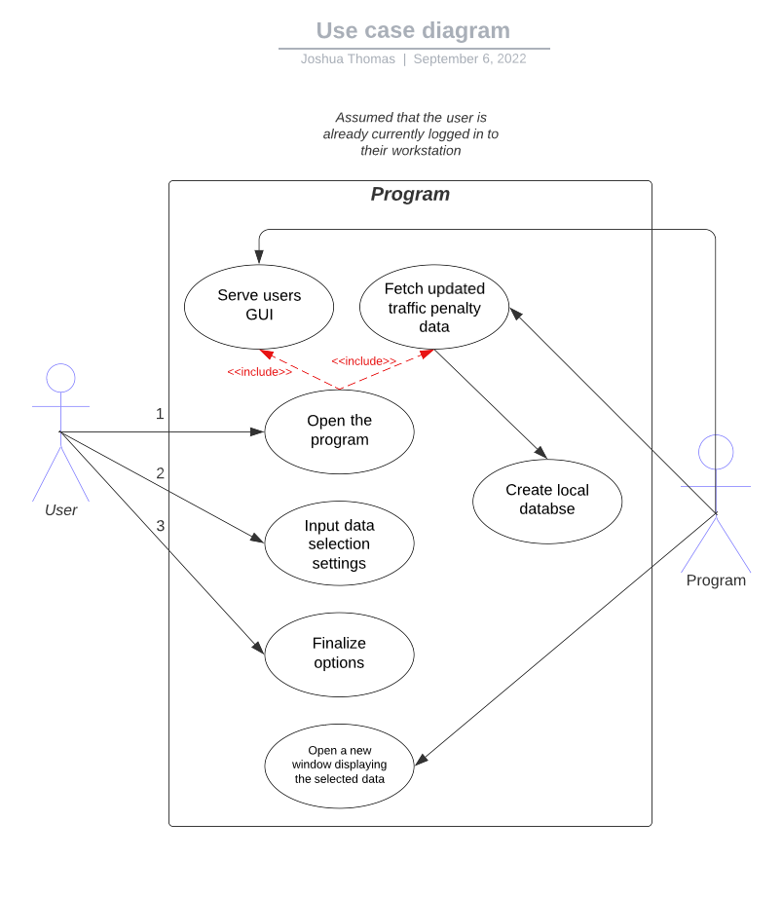A user wishes to view a histogram of all traffic penalty data occurring at a particular location code “7296”. The user must select; Location code; 7296, the user must also select the ‘display data’ checkbox and indicate the type of display as a histogram. This particular search could be used to analyse whether a particular location is higher or lower risk of traffic penalties occurring, of which a further analysis would be able to indicate why this issue is present and possible solutions to mitigate the problem.   
**Use case diagram:**

# Software Design and System Components

## Software Design

A block diagram/flowchart of how your software might work

## System Components

### Functions

Preliminary list of all functions in the software. For each function in the list the following information is provided:

* a brief description of what it does (1 or 2 sentences);
* a list of the input parameters, and their data types, and what they are used for;
* a list of any side effects caused by the function (ie change global or member variables, changes data passed by reference from calling function etc)
* a description of the function’s return value

### Data Structures / Data Sources

List of all data structures in the software (eg linked lists, trees, arrays etc) or eternal data sources. For each data structure in the list the following information is provided:

* Type of structure (tree, list etc),
* Description of where and how it is used
* List of data members, and what each one is for do
* List of functions that use it

### Detailed Design

Pseudocode for all non-standard / non-trivial algorithms that operate on data structures

# User Interface Design

This is your initial interface design. Describe the tools you used for this design stage and any key findings that informed your design. This introduction is descriptive and should explain what you have completed for the actual design work you will present in the sub-sections below.

## Structural Design

Structural design refers to the navigational and information structure of your product – the structure that supports the interface layout. How will you structure your product? How will you group your information? How will you navigate through your product? Why? This can take the form of a diagram showing structure and hierarchy, supported by a discussion and justification of your choices. Why have you made these design choices? Describe and outline the structure of your interface and of your information.

## Visual Design

Detail your visual design: Layout, visual elements, icons, graphics, style, colour, fonts general screen designs. This can be sketches, wireframes, mockups etc, supported by a discussion, explanation, and justification of your choices.